## Case Study Submission Template

1. Name: **Tirthankar Gupta**
2. Employee ID: **758489**
3. Email ID: [**gupta.tirthankar4@gmail.com**](mailto:gupta.tirthankar4@gmail.com) **/ tirthankar.g@tcs.com**
4. Git Repository URL: [**https://github.com/Tirthankar17/BootCampCaseStudy.git**](https://github.com/Tirthankar17/BootCampCaseStudy.git)
5. **Screenshot of Dockerfile:**

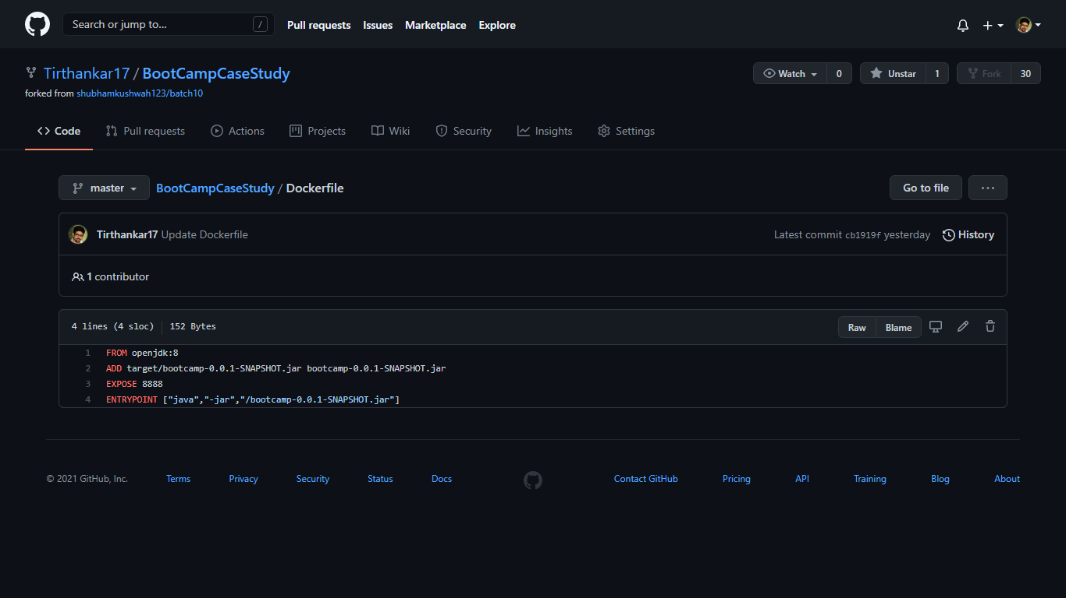

1. **Screenshot of Jenkinsfile:**

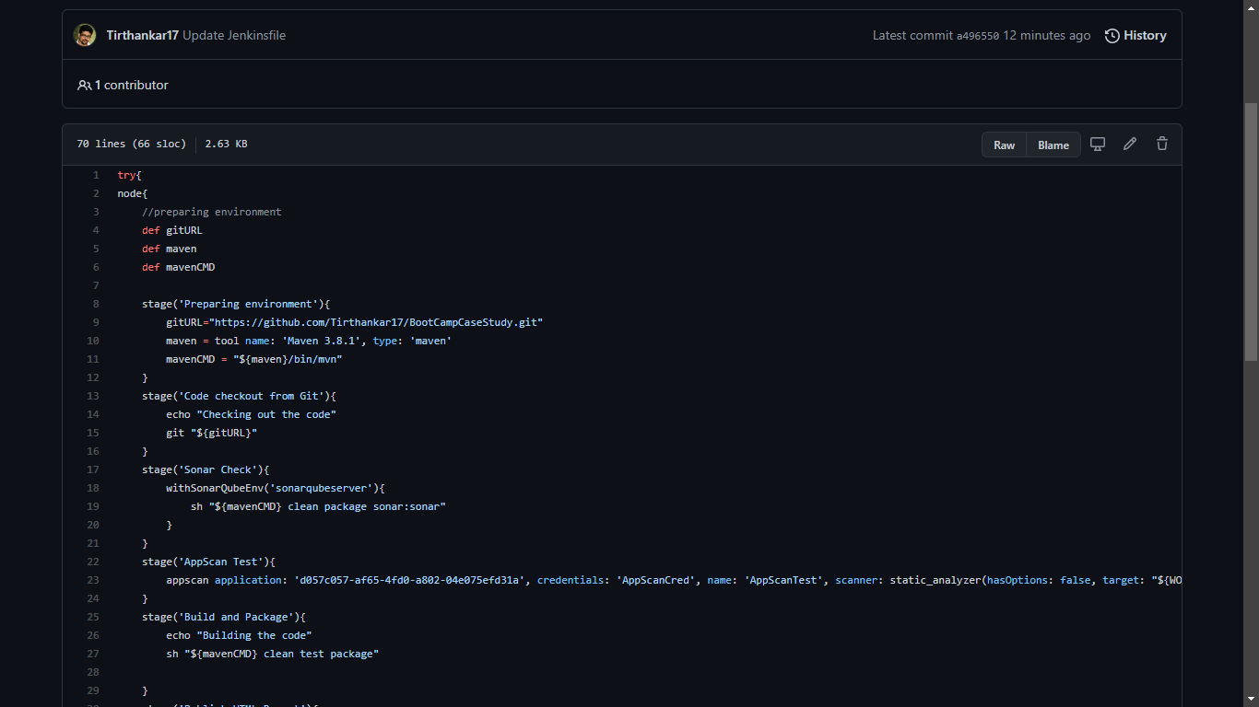

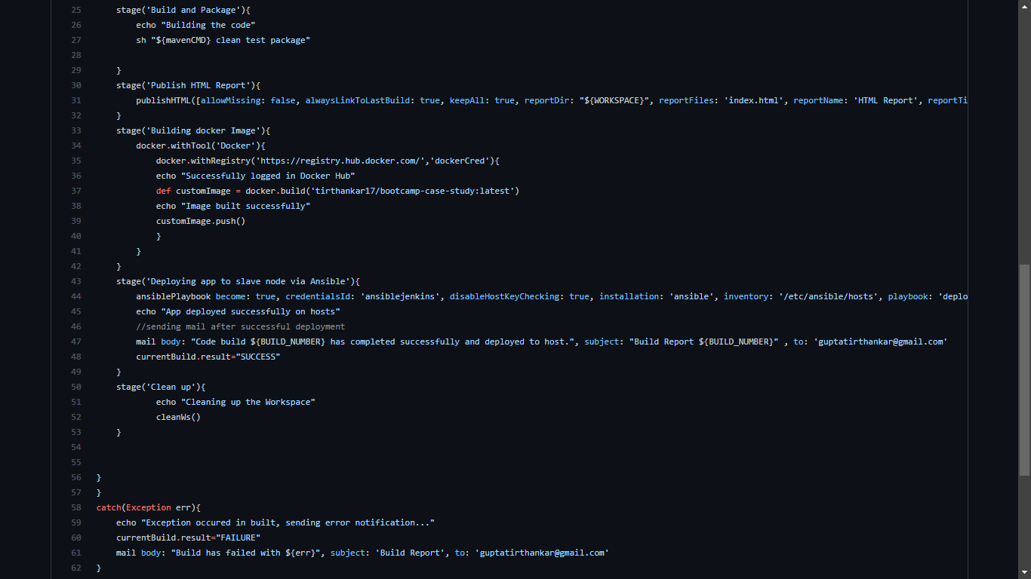

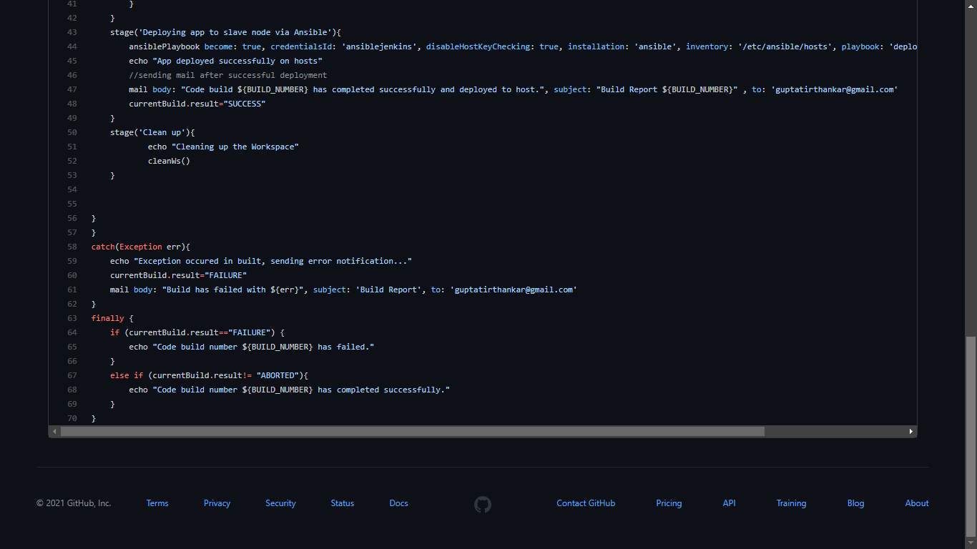

1. **Uploaded Jenkins log file in Repo:**

(Only providing sample screenshots of beginning and End, entire log is uploaded in PDF format in Repo)

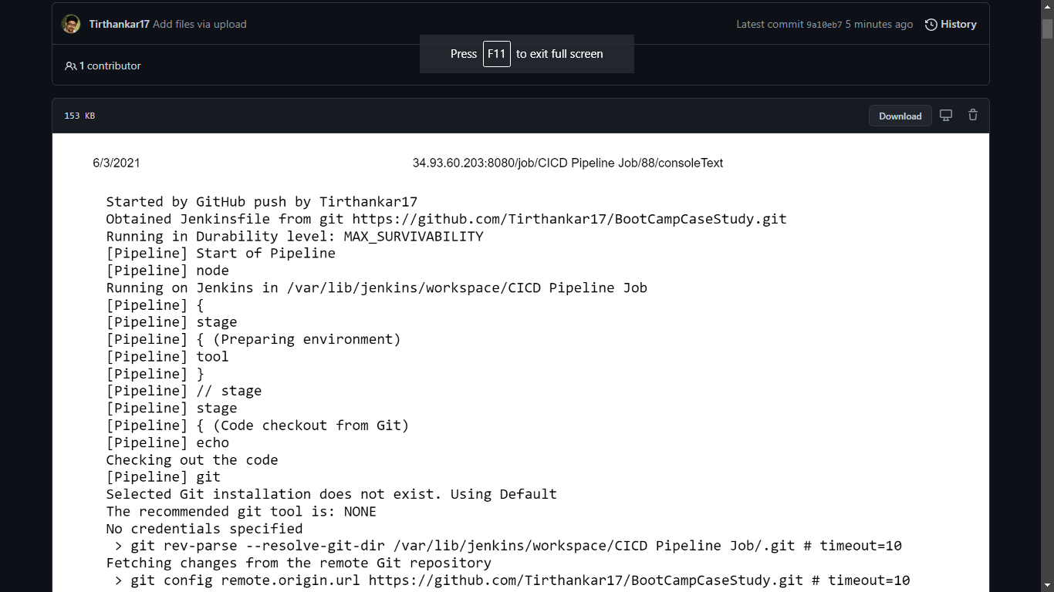

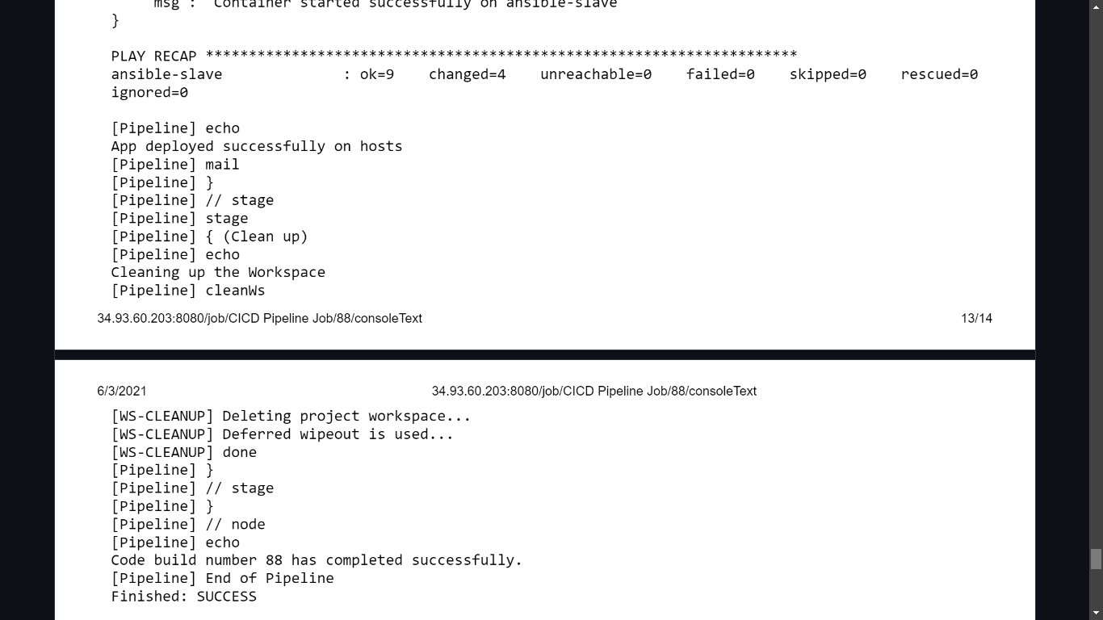

1. **Screenshot of Jenkins Pipeline Status: Every box is Green**

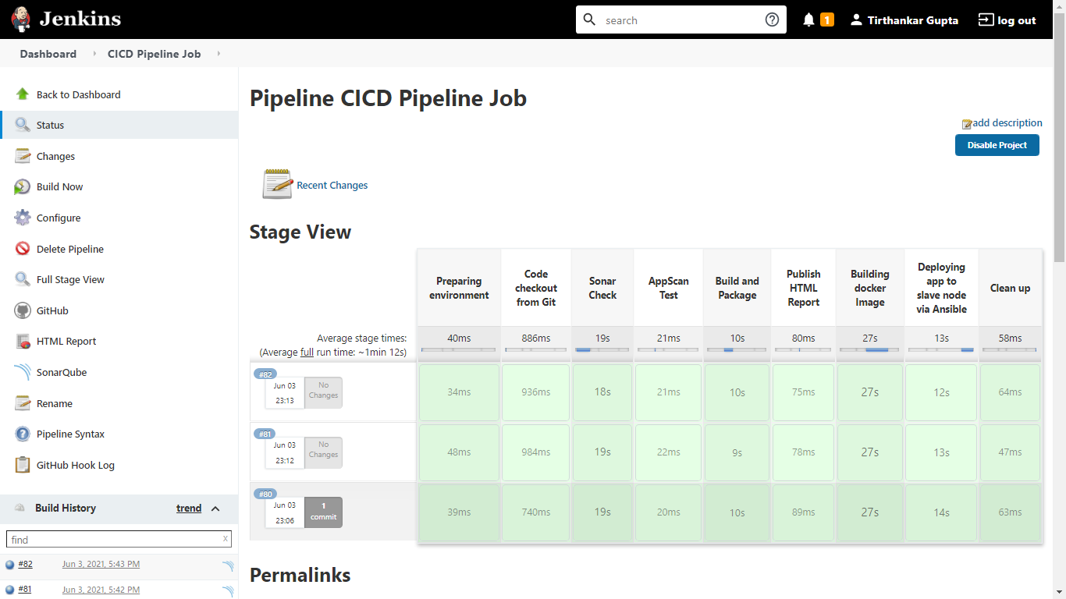

1. **Screenshot of Email Notification of Build in my Inbox:**

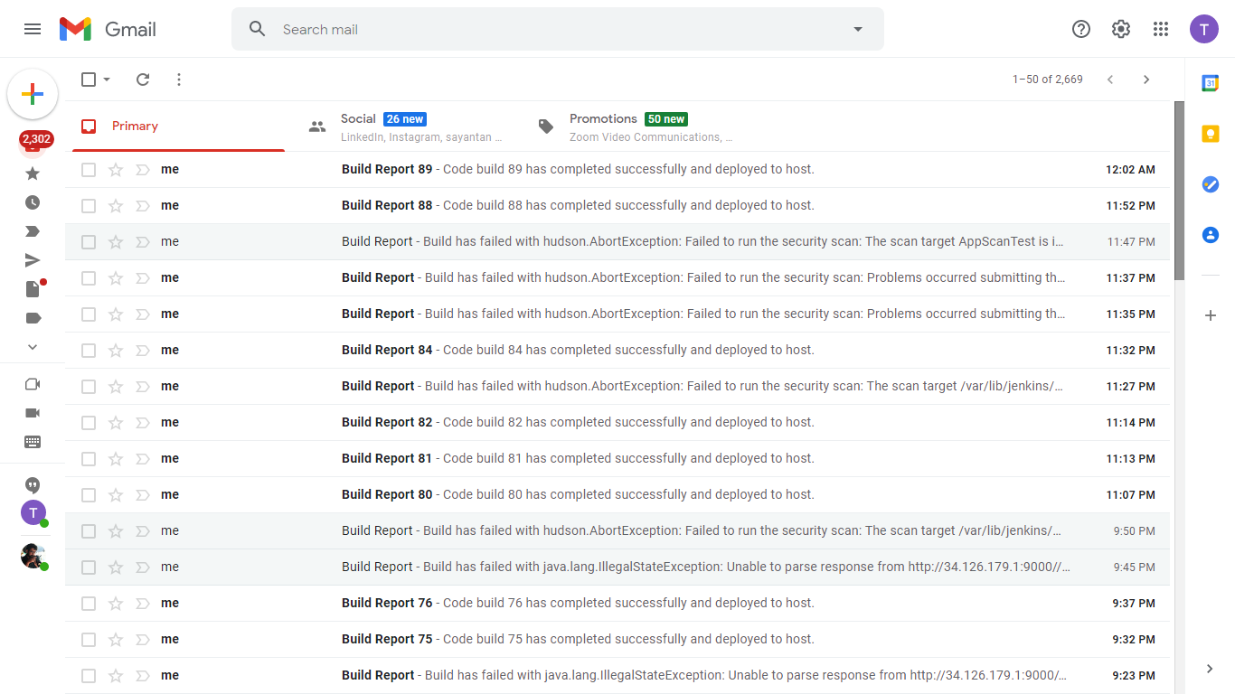

Success email:

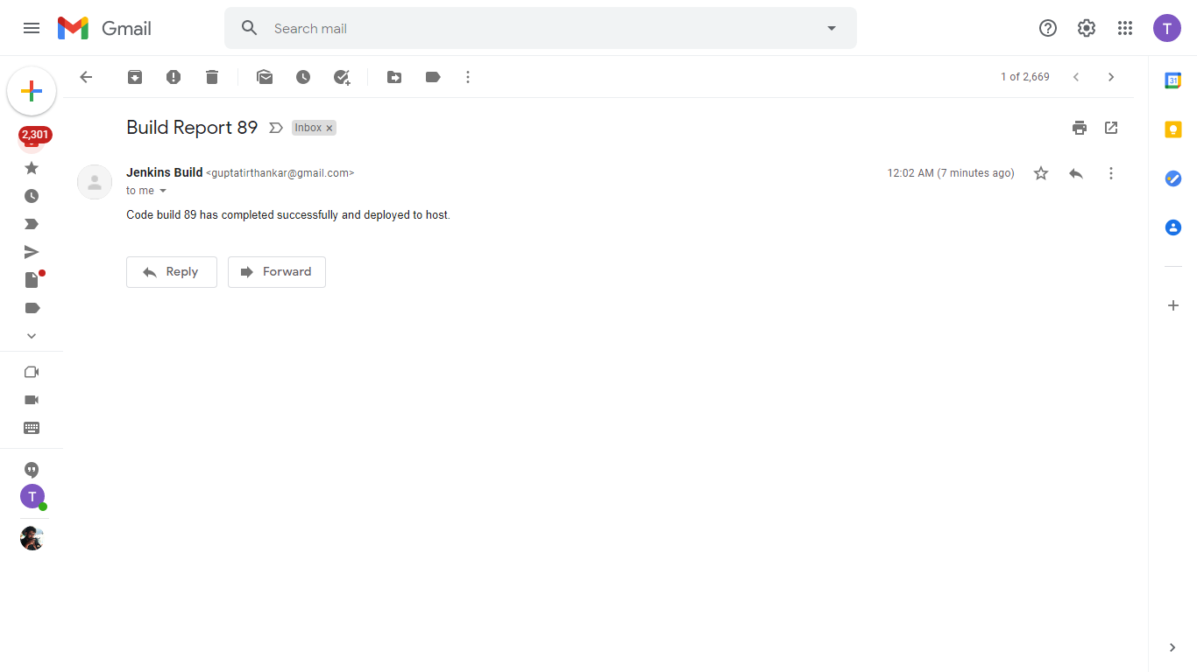

Failure email with error details:

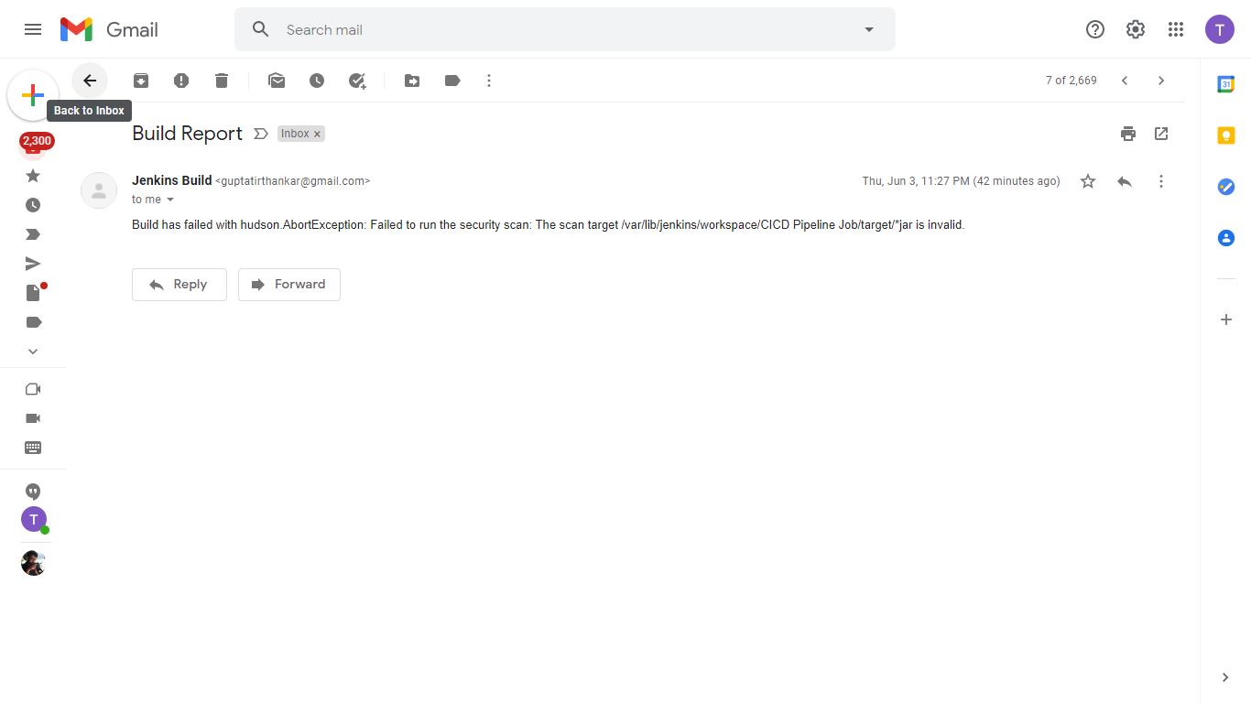

1. **Screenshot of SonarQube Report:**

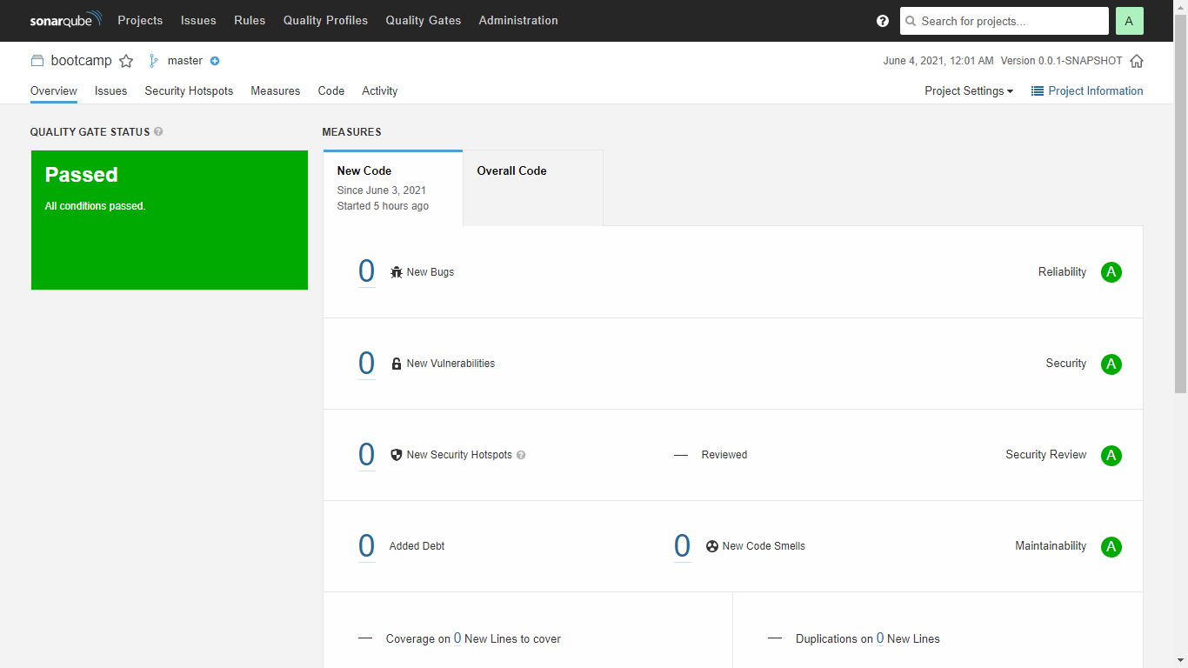

1. **Screenshot of AppScan Report: (AppScan on Cloud Trial version)**

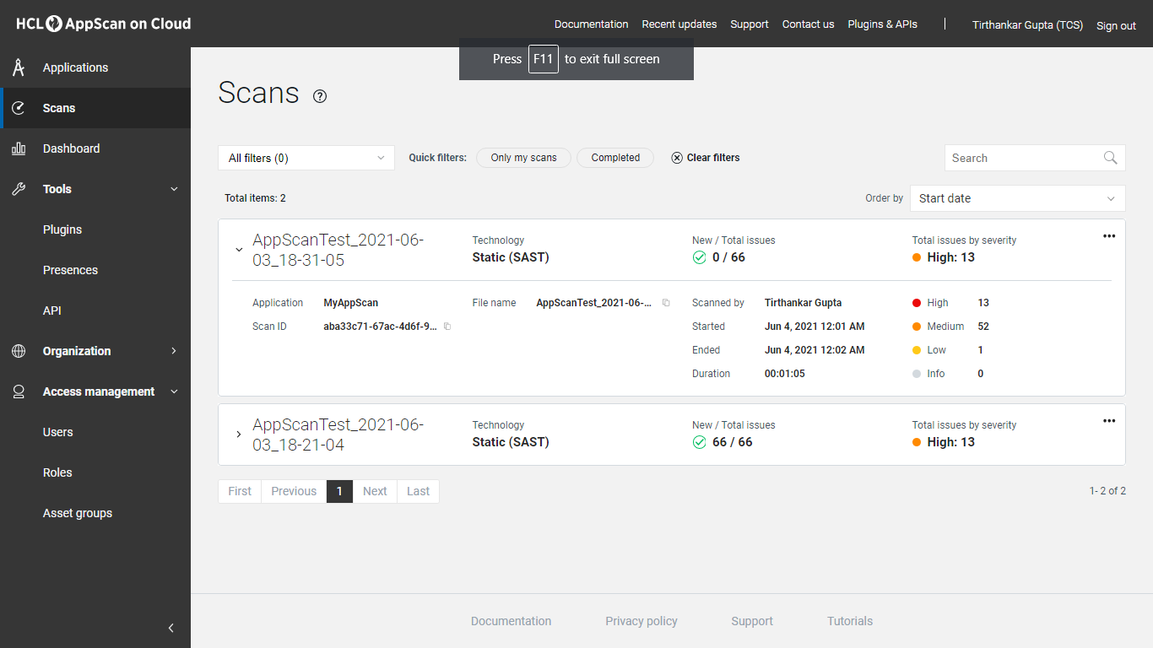

1. **Screenshot of Ansible Playbook Execution logs: (Directly from Jenkins log)**

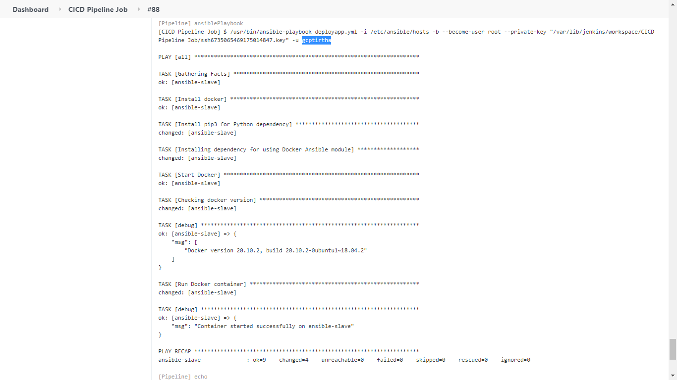

Providing additional screenshot from GCP Master Node console as well, run from the workspace in Jenkins:

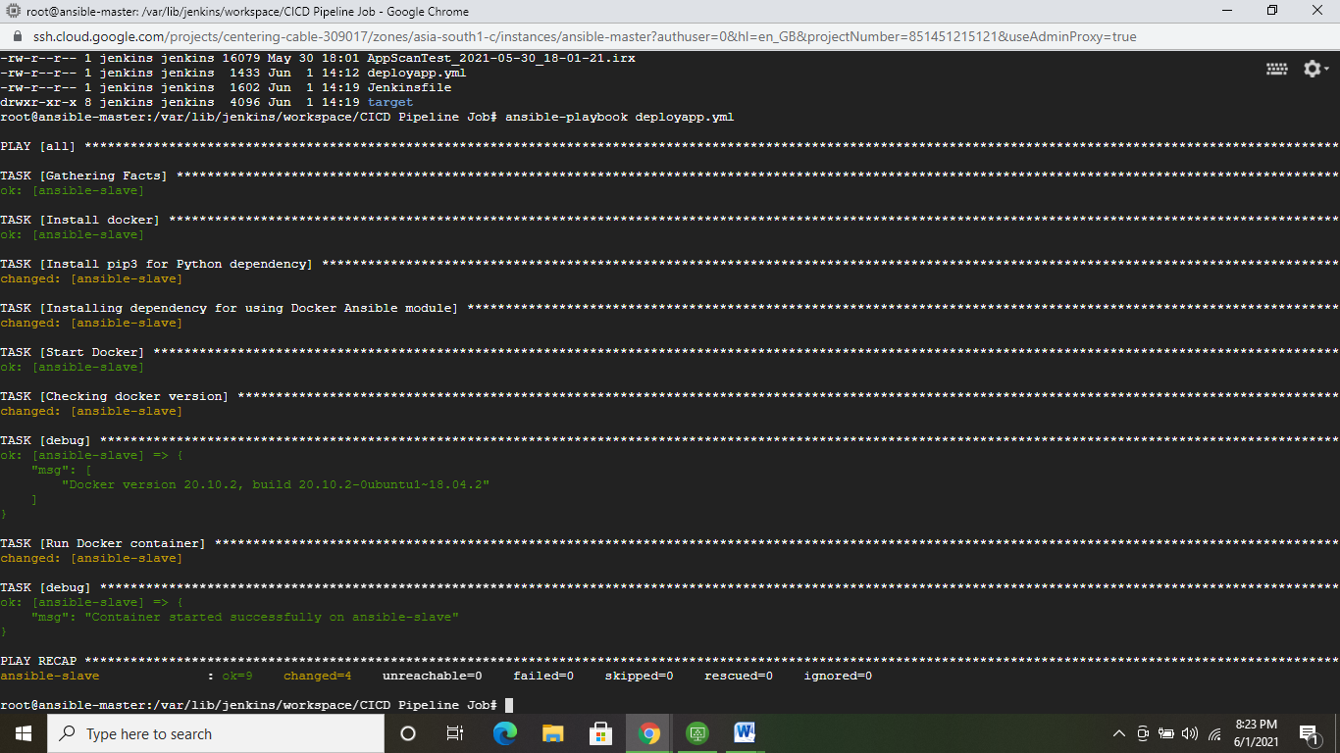

1. **Screenshot of working application homepage on GCP:**

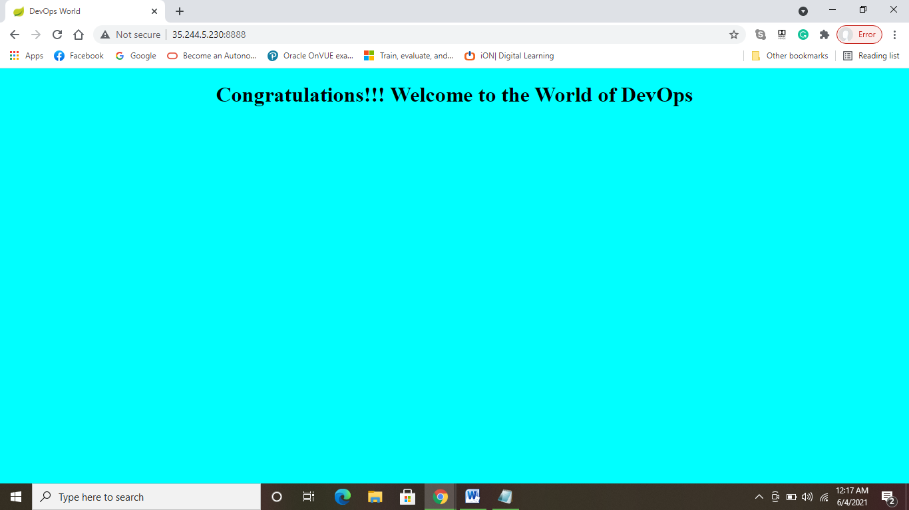

**Additionally providing screenshot of running container in slave node:**

